STANDARDS & OBJECTIVES: TEKS & VERTICAL ALIGNMENT
TEKS:
G-GPE 4
Drawing the best sets of squares that fit the four faces of Timon, Chris, Andrew, and Nathan in the provided video, and also calculating areas of the squares using area models.
The student is expected to apply skills taught to them in this grade and previous grades in drawing the best squares possible.
- The student needs to know how to subtract and add
- The student needs to know how to solve multiplication
- The students will need to recall the information taught in 3rd grade, solve one step and two-step problems involving multiplication and division
- I will make the students aware of the TEKS by asking them what they did today at the end of my lesson. I anticipate they will say …. Once I get several suggestions about what they did today. I will tell them the objective.

MATERIALS:
Paper plates
Anglers
Videos

QUESTIONS FOR STUDENT THINKING
What do you notice? What do you wonder? Where do you think we should start? What is some information that you already know? How can that information help you with this task? Can you apply another manipulative in solving? How does this make the strategies different? How do they relate?

PROCEDURES:
ACT 1:
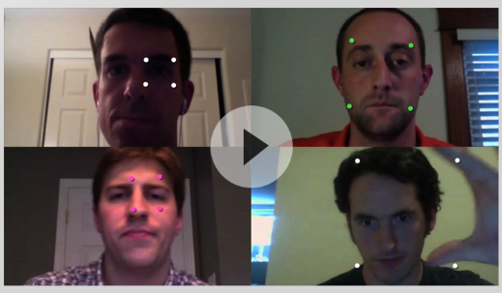
What does the student notice? What do they wonder?
I notice _
I wonder _
Allow the students one minute to turn and talk with their elbow partners. I will create a class anchor chart: I notice _
I wonder _
I will record all the student responses on the anchor chart.

ACT 2
Problem to be solved: The student will need to come up with a rule that tells us how any attempt at drawing a square ranks against any other. The attempts may be done using the following resources: sides, areas, angles, and coordinates, and still observe the rule that does not hold up for every case. I will ask them to test their rule against lots of different cases. Their rule has to work using cases that are very large or really small. If they are convinced their rule works, you may want to suggest cases.
Materials: I will provide the students, who are working individually with the video. I will also provide paper plates and anglers to complete the rest of the task.
Student Organization- Each student will work individually on the task for 10 –20 minutes. I will monitor and make decisions based on the outcome available.
Questions for students: How is it possible to draw the best square? What skills do you already have to carry out the task? How can the skills help in carrying out the task? Why? Do you know of another way to carry out this task?
ANTICIPATED RESPONSES: How many squares are needed for this exercise? Can the use of markers and set anglers be helpful in this exercise? The students can use the fact that the best solution is to use the fact that a square is the quadrilateral that encloses the most area for a given perimeter. They can also take a ratio of the quadrilateral area and compare it to what his area should have been with a square and get a score.
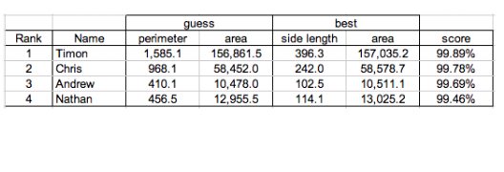

ACT 3: Students will go through the solved example to understand further how it was done (5 minutes). Then each student will take a moment to describe to the class their strategies and how they solved them. I will record on the white board different strategies used. (5 minutes)
How the strategies are different? How are they the same? Can another student explain a different way they can be solved? How can the strategies be recreated?

References: https://mikewiernicki.com/3-act-tasks/
https://gfletchy.com/3-act-lessons/

